23CSE202 DATABASE MANAGEMENT SYSTEMS
S3 B.Tech CSE
Department of Computer Science and Engineering
Amrita School of Computing, Amritapuri Campus
3. ER Diagram, Relational Schema and Normalization Document
Group No : D6
Team Members :
Roll No | Student Name
AM.SC.U4CSE25343 | Vedananda
AM.SC.U4CSE25334 | Yaswanth
AM.SC.U4CSE25345 | Saket
AM.SC.U4CSE25337 | Swapnil

Project Title : Online Food Delivery System

3.1. Detailed description of the project
The Online Food Delivery System is a web application built with HTML, Tailwind CSS, Java servlets on Apache Tomcat 10.1 and a PostgreSQL database and inspired by Swiggy and Zomato, allowing a customer to register, browse restaurants, order food, pay, track the delivery and leave feedback. The whole business is made consistent with a back-end database. The system consists of eleven tables: nine entities (Customer, Address, Restaurant, Menu_Item, Cart, Orders, Payment, Delivery_Agent and Feedback) and two associative tables (Cart_Item and Order_Item). The following paragraphs describe these entities and their attributes, the relationships between them, the various classes of users and the business rules that the schema must enforce.
Entities and attributes. A Customer (customer_id, name, email, phone, password) registers once and may save several delivery Addresses (address_id, street, city, pincode, address_type). A Restaurant (restaurant_id, name, location, cuisine_type, rating) publishes a catalogue of Menu_Item records (item_id, item_name, price, category, availability), each belonging to exactly one restaurant. Every customer owns a single, ongoing shopping Cart (cart_id) into which menu items are added before checkout. Once checkout is confirmed the cart contents are converted into an Orders record (order_id, order_date, status, total_amount) linked to the ordering customer and the source restaurant. A Delivery_Agent (agent_id, name, phone, vehicle_no, availability_status) is assigned to the order afterwards by the dispatcher, once the order has been placed, and delivers it. The individual food items within an order are captured as Order_Item rows (quantity, unit_price), each Orders record settles through exactly one Payment (payment_id, amount, method, status, payment_date), and the customer may leave one Feedback (feedback_id, rating, comments, feedback_date) per completed order.
Relationships. A customer has many addresses (1:N) but each address belongs to one customer; a customer owns exactly one cart (1:1); a customer places many orders and gives many pieces of feedback (1:N in both cases). A restaurant offers many menu items and receives many orders (1:N). Because a shopping basket or an order can hold several different dishes, and the same dish can appear in many baskets or orders, the cart-to-menu_item and orders-to-menu_item associations are many-to-many (M:N), resolved by the Cart_Item and Order_Item associative relationships, which carry the quantity (and, for orders, the unit_price actually charged). A delivery agent delivers many orders over time but handles one order at a time (1:N), and each order results in at most one payment and at most one feedback entry (1:1).
Users of the system. Three classes of user are modelled. The Customer browses, orders, pays and leaves feedback through the web interface. The Restaurant owner/manager and the Delivery Agent are represented by the system's automatic dispatcher, which moves each order through its stages and assigns a free agent, so their status changes are recorded without a separate login. The Administrator role is not implemented in the prototype.
Business rules.
- Every order must be linked to exactly one customer and exactly one restaurant; all menu items within a single order must belong to that same restaurant.
- An order cannot be created from an empty cart, and every order must contain at least one order item.
- A payment record cannot exist without a corresponding order, and every order eventually requires exactly one payment (status is Pending, Completed or Failed; the prototype records each payment as Completed at checkout).
- A delivery agent can be assigned to an order only if their availability_status is ‘Free’; once assigned, the agent is marked unavailable until the order is delivered.
- Feedback can be submitted only for orders whose status is ‘Delivered’, and at most one feedback entry is allowed per order.
- The total_amount on an order is a derived value equal to the sum of (quantity × unit_price) across its order items, plus a fixed delivery fee of ₹2.99.
- A customer may delete a saved address without affecting past orders. The order keeps its record, and its delivery_address_id is set to NULL.

3.2. ER Diagram
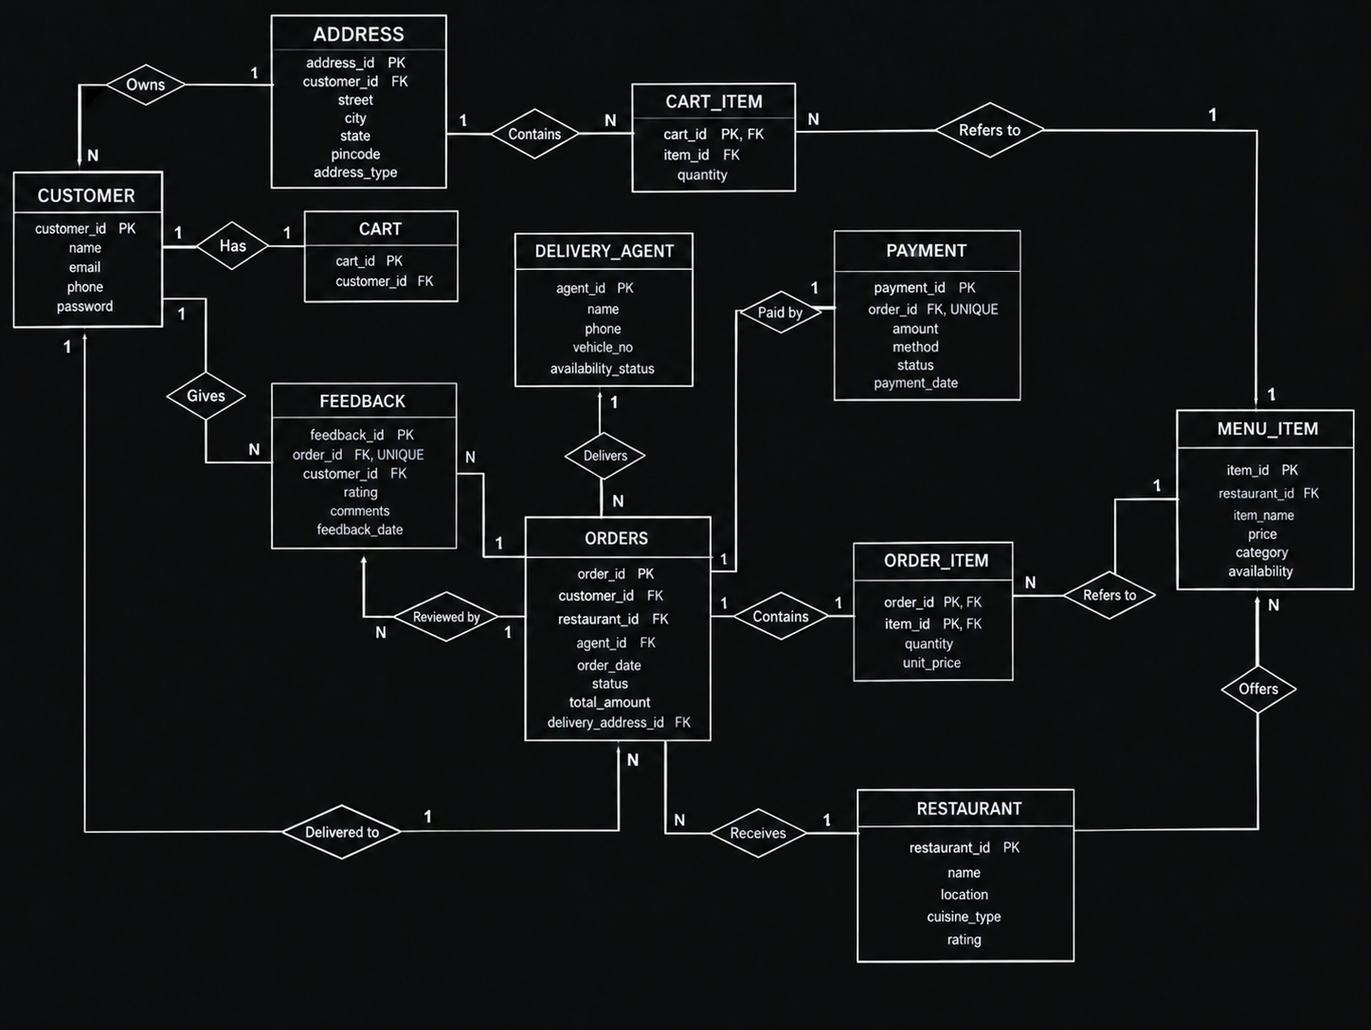
Cardinality / participation :
- CUSTOMER – ADDRESS: 1:N, total participation on ADDRESS (an address must belong to a customer), partial on CUSTOMER (a customer may have zero addresses initially).
- CUSTOMER – CART: 1:1, total participation on both sides (every registered customer is assigned one cart, and every cart belongs to a customer).
- CUSTOMER – ORDERS: 1:N, total on ORDERS, partial on CUSTOMER.
- CUSTOMER – FEEDBACK: 1:N, total on FEEDBACK, partial on CUSTOMER.
- RESTAURANT – MENU_ITEM: 1:N, total on MENU_ITEM, partial on RESTAURANT.
- RESTAURANT – ORDERS: 1:N, total on ORDERS, partial on RESTAURANT.
- CART – MENU_ITEM (CART_ITEM): M:N, partial on both sides (a cart may be empty; a menu item may be in no cart).
- ORDERS – MENU_ITEM (ORDER_ITEM): M:N, total participation on ORDERS (an order must have at least one item), partial on MENU_ITEM.
- ORDERS – ADDRESS: 1:N, partial on both sides (an order may have no address recorded, and an address may be used by no order). Deleting an address sets the order's delivery_address_id to NULL (ON DELETE SET NULL).
- ORDERS – PAYMENT: 1:1, total participation on both sides.
- DELIVERY_AGENT – ORDERS: 1:N, partial on both sides (an order may not yet have an agent assigned; an agent may currently have no orders).
- ORDERS – FEEDBACK: 1:1, partial on both sides (not every order has received feedback).

3.3. Relational Schema
Applying the standard ER-to-relational mapping rules — a table for every strong entity, foreign keys to represent 1:N relationships, and a bridge table for every M:N relationship — the ER diagram above converts to the eleven relations below. Primary keys are underlined; foreign keys are annotated ‘FK’ with the table they reference.
CUSTOMER ( ̲c̲u̲s̲t̲o̲m̲e̲r̲_̲i̲d , name, email, phone, password )
Primary Key: customer_id
Attribute | Notes
customer_id | PK
name | —
email | UNIQUE, NOT NULL
phone | NOT NULL, 10 digits
password | —
ADDRESS ( ̲a̲d̲d̲r̲e̲s̲s̲_̲i̲d , customer_id, street, city, pincode, address_type )
Primary Key: address_id | Foreign Key: customer_id → CUSTOMER
Attribute | Notes
address_id | PK
customer_id | FK → CUSTOMER, NOT NULL
street | —
city | —
pincode | —
address_type | Home / Work / Other
RESTAURANT ( ̲r̲e̲s̲t̲a̲u̲r̲a̲n̲t̲_̲i̲d , name, location, cuisine_type, rating )
Primary Key: restaurant_id
Attribute | Notes
restaurant_id | PK
name | —
location | —
cuisine_type | —
rating | 0–5, average of feedback
MENU_ITEM ( ̲i̲t̲e̲m̲_̲i̲d , restaurant_id, item_name, price, category, availability )
Primary Key: item_id | Foreign Key: restaurant_id → RESTAURANT
Attribute | Notes
item_id | PK
restaurant_id | FK → RESTAURANT, NOT NULL
item_name | —
price | —
category | Starter / Main / Dessert / Drink / Snack / Bread
availability | boolean
CART ( ̲c̲a̲r̲t̲_̲i̲d , customer_id )
Primary Key: cart_id | Foreign Key: customer_id → CUSTOMER (UNIQUE, enforces 1:1)
Attribute | Notes
cart_id | PK
customer_id | FK → CUSTOMER, UNIQUE, NOT NULL
CART_ITEM ( ̲c̲a̲r̲t̲_̲i̲d , ̲i̲t̲e̲m̲_̲i̲d , quantity )
Primary Key: (cart_id, item_id) — composite | FKs: cart_id → CART, item_id → MENU_ITEM
Attribute | Notes
cart_id | PK, FK → CART
item_id | PK, FK → MENU_ITEM
quantity | —
ORDERS ( ̲o̲r̲d̲e̲r̲_̲i̲d , customer_id, restaurant_id, agent_id, delivery_address_id, order_date, status, total_amount )
Primary Key: order_id | FKs: customer_id → CUSTOMER, restaurant_id → RESTAURANT, agent_id → DELIVERY_AGENT (nullable), delivery_address_id → ADDRESS (nullable)
Attribute | Notes
order_id | PK
customer_id | FK → CUSTOMER, NOT NULL
restaurant_id | FK → RESTAURANT, NOT NULL
agent_id | FK → DELIVERY_AGENT, NULLable until assigned
delivery_address_id | FK → ADDRESS, nullable (set to NULL if the address is deleted)
order_date | —
status | Placed / Preparing / Out-for-delivery / Delivered (Cancelled is reserved for future use)
total_amount | derived = Σ(quantity × unit_price) + delivery fee ₹2.99
ORDER_ITEM ( ̲o̲r̲d̲e̲r̲_̲i̲d , ̲i̲t̲e̲m̲_̲i̲d , quantity, unit_price )
Primary Key: (order_id, item_id) — composite | FKs: order_id → ORDERS, item_id → MENU_ITEM
Attribute | Notes
order_id | PK, FK → ORDERS
item_id | PK, FK → MENU_ITEM
quantity | —
unit_price | price at the time of ordering
PAYMENT ( ̲p̲a̲y̲m̲e̲n̲t̲_̲i̲d , order_id, amount, method, status, payment_date )
Primary Key: payment_id | Foreign Key: order_id → ORDERS (UNIQUE, enforces 1:1)
Attribute | Notes
payment_id | PK
order_id | FK → ORDERS, UNIQUE, NOT NULL
amount | —
method | UPI / Card / Cash on Delivery
status | Pending / Completed / Failed
payment_date | —
DELIVERY_AGENT ( ̲a̲g̲e̲n̲t̲_̲i̲d , name, phone, vehicle_no, availability_status )
Primary Key: agent_id
Attribute | Notes
agent_id | PK
name | —
phone | —
vehicle_no | —
availability_status | Free / Busy
FEEDBACK ( ̲f̲e̲e̲d̲b̲a̲c̲k̲_̲i̲d , order_id, customer_id, rating, comments, feedback_date )
Primary Key: feedback_id | FKs: order_id → ORDERS (UNIQUE), customer_id → CUSTOMER
Attribute | Notes
feedback_id | PK
order_id | FK → ORDERS, UNIQUE, NOT NULL
customer_id | FK → CUSTOMER, NOT NULL
rating | 1–5
comments | —
feedback_date | —

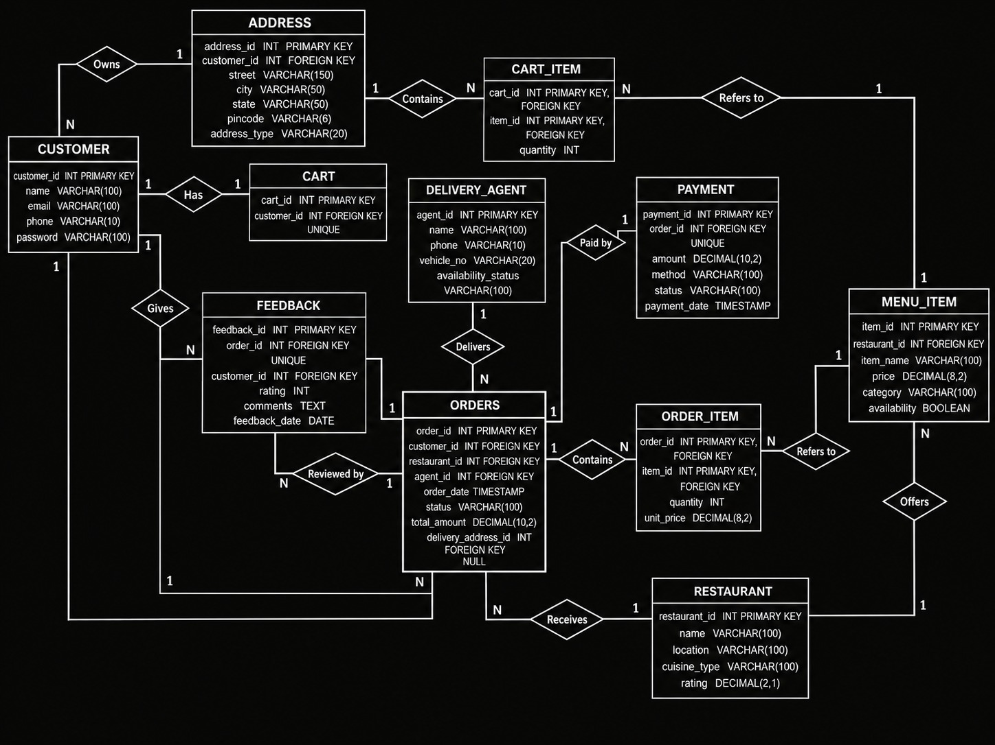

3.4. Normalization and Functional Dependency Analysis
To demonstrate the normalization process, consider the flat, denormalised report a restaurant might initially design to print an order receipt — before the schema above was derived. All order, customer, restaurant, delivery-agent and item details are stored together in one wide relation:
ORDER_DETAILS ( order_id, order_date, customer_id, customer_name, customer_email, restaurant_id, restaurant_name, restaurant_location, agent_id, agent_name, agent_phone, item_id, item_name, item_price, quantity, payment_method, payment_amount )

Step 1 — Identifying functional dependencies (FDs)
Examining how a receipt is filled in gives the following functional dependencies:
- order_id → order_date, customer_id, restaurant_id, agent_id, payment_method, payment_amount
- customer_id → customer_name, customer_email
- restaurant_id → restaurant_name, restaurant_location
- agent_id → agent_name, agent_phone
- item_id → item_name, item_price
- order_id, item_id → quantity
FD (1) holds because once an order is placed, its date, the customer who placed it, the restaurant it came from, the agent (if any) and its payment are all fixed. FDs (2), (3) and (4) hold because customer, restaurant and agent master data does not depend on any particular order. FD (5) holds because an item's name and listed price are catalogue properties of the item, not of any one order. FD (6) is necessary because the same item can appear in many orders and the same order can contain many items — only the pair identifies how many units of that item were ordered.

Step 2 — Candidate key and attribute closure
Neither order_id nor item_id alone functionally determines every attribute of ORDER_DETAILS (order_id alone cannot fix which item_name/item_price/quantity row we mean, since one order has many items; item_id alone cannot fix order_date/customer_id, since one item recurs across many orders). We therefore test the composite attribute set K = {order_id, item_id} by computing its closure K⁺:
- K⁰ = { order_id, item_id }
- Apply order_id → order_date, customer_id, restaurant_id, agent_id, payment_method, payment_amount ⇒ K¹ = K⁰ ∪ {order_date, customer_id, restaurant_id, agent_id, payment_method, payment_amount}
- Apply item_id → item_name, item_price ⇒ K² = K¹ ∪ {item_name, item_price}
- Apply customer_id → customer_name, customer_email (customer_id ∈ K²) ⇒ K³ = K² ∪ {customer_name, customer_email}
- Apply restaurant_id → restaurant_name, restaurant_location ⇒ K⁴ = K³ ∪ {restaurant_name, restaurant_location}
- Apply agent_id → agent_name, agent_phone ⇒ K⁵ = K⁴ ∪ {agent_name, agent_phone}
- Apply {order_id, item_id} → quantity ⇒ K⁶ = K⁵ ∪ {quantity} = all 17 attributes of ORDER_DETAILS
Since K⁺ contains every attribute of the relation, K = {order_id, item_id} is a superkey. It is minimal (and hence a candidate key) because dropping either attribute strictly shrinks the closure: {order_id}⁺ excludes item_name, item_price and quantity, and {item_id}⁺ excludes order_date, customer_id, restaurant_id, agent_id, payment_method and payment_amount. No other minimal attribute combination determines all 17 attributes, so (order_id, item_id) is the sole candidate key, and it is also chosen as the primary key of ORDER_DETAILS.

Step 3 — 1NF to 2NF (removing partial dependencies)
2NF requires that every non-key attribute be fully functionally dependent on the whole candidate key, not on just part of it. Here the candidate key is composite, {order_id, item_id}, yet order_date, customer_id, customer_name, customer_email, restaurant_id, restaurant_name, restaurant_location, agent_id, agent_name, agent_phone, payment_method and payment_amount all depend only on order_id, and item_name, item_price depend only on item_id — these are partial dependencies and must be removed by decomposition:
- ORDER_INFO ( order_id, order_date, customer_id, customer_name, customer_email, restaurant_id, restaurant_name, restaurant_location, agent_id, agent_name, agent_phone, payment_method, payment_amount ) — PK: order_id
- ITEM_INFO ( item_id, item_name, item_price ) — PK: item_id
- ORDER_LINE ( order_id, item_id, quantity ) — PK: (order_id, item_id), FKs to ORDER_INFO and ITEM_INFO
In each of these three relations every non-key attribute now depends on the entire (in ORDER_LINE, composite) key, so all three are in 2NF.

Step 4 — 2NF to 3NF (removing transitive dependencies)
3NF additionally forbids transitive dependencies of non-key attributes through another non-key attribute. ORDER_INFO still has three: order_id → customer_id → {customer_name, customer_email}; order_id → restaurant_id → {restaurant_name, restaurant_location}; and order_id → agent_id → {agent_name, agent_phone}. Each is removed by projecting the transitively-dependent attributes into their own relation, keyed on the intermediate determinant:
- ORDERS ( order_id, order_date, customer_id, restaurant_id, agent_id, payment_method, payment_amount ) — PK: order_id; FKs: customer_id, restaurant_id, agent_id
- CUSTOMER ( customer_id, customer_name, customer_email ) — PK: customer_id
- RESTAURANT ( restaurant_id, restaurant_name, restaurant_location ) — PK: restaurant_id
- DELIVERY_AGENT ( agent_id, agent_name, agent_phone ) — PK: agent_id
- ITEM_INFO and ORDER_LINE carry over unchanged from Step 4, since item_id → {item_name, item_price} was already a direct (non-transitive) dependency on the whole key of ITEM_INFO.
Every relation is now in 3NF: for every non-trivial FD X → Y remaining in any relation, X is a superkey of that relation (e.g. in ORDERS, order_id is the only determinant and it is the primary key).

Step 5 — 3NF to BCNF
BCNF strengthens 3NF by requiring that X be a superkey for every non-trivial FD X → Y, with no exception carved out for prime attributes. A relation can be in 3NF but not BCNF only when it has two or more overlapping candidate keys and a determinant that is itself a proper subset of one candidate key but not a superkey of the whole relation. Inspecting the decomposed relations — ORDERS, CUSTOMER, RESTAURANT, DELIVERY_AGENT, ITEM_INFO and ORDER_LINE — each has exactly one candidate key (its stated primary key, or the composite (order_id, item_id) for ORDER_LINE), and the only functional dependencies present are the primary key determining the remaining attributes of that same relation. There are no overlapping candidate keys and no determinant other than the primary key, so every relation already satisfies BCNF; no further decomposition is required. This final schema — ORDERS, CUSTOMER, RESTAURANT, DELIVERY_AGENT, ITEM_INFO (renamed MENU_ITEM) and ORDER_LINE (renamed ORDER_ITEM) — is exactly the set of relations presented in Section 3.3, now extended in the full design with CART, CART_ITEM, PAYMENT, ADDRESS and FEEDBACK, each of which is similarly keyed on a single primary key with no partial or transitive dependencies, and is therefore likewise in BCNF.
Significance of the analysis: normalising to BCNF eliminates update, insertion and deletion anomalies that the flat ORDER_DETAILS table would otherwise suffer — for example, correcting a misspelt restaurant name would previously require updating every order row from that restaurant, and it would have been impossible to record a new restaurant with no orders yet, or a new menu item with no orders yet, without inserting a fictitious order row. Splitting the design along the functional dependencies removes all three anomalies while keeping every relationship recoverable through the foreign keys, exactly as modelled in the ER diagram in Section 3.2.
Note on payments: payment_method and payment_amount are moved into their own PAYMENT relation because each order has exactly one payment. This makes the 1:1 relationship explicit and avoids repeating payment data in ORDERS.

